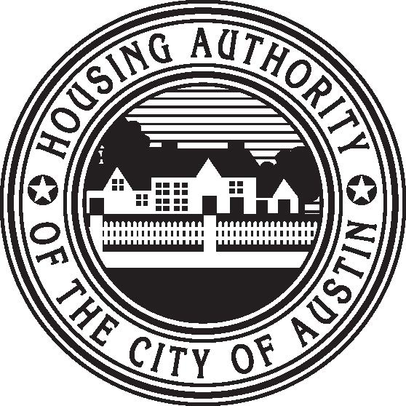 | Housing Authority of the City of Austin  Bringing Opportunity Home  1124 South IH 35, Austin, TX 78704 (512) 477-4488

October 26, 2021

Re: Notice of proposed changes to the Housing Choice Voucher (HCV) Administrative Plan

The Housing Authority of the City of Austin (HACA) is announcing a public comment period for the proposed changes to HACA’s Housing Choice Voucher Administrative Plan.

HACA will receive written comments regarding the proposed changes during a 30-day public comment period to commence October 26, 2021 through November 26, 2021. All written comments are emailed to executive@hacanet or mailed or hand delivered to the following address:

Housing Authority of the City of Austin
Attn: President and CEO
1124 S IH 35
Austin, TX 78704

A copy of the proposed changes is available in the links below. Copies of the full HCV Administrative Plan are available at the HACA Central Office (1124 S IH 35, Austin, TX 78704) or on our website at www.hacanet.org.

The Housing Authority of the City of Austin Board of Commissioners will vote on the adoption of this policy on Thursday, December 16, 2021 at 12:00 noon at the HACA Central Office located at 1124 S IH 35, Austin, TX 78704. The date, time and location of the meeting are subject to change. See HACA website at www.hacanet.org for updates.

If you have any questions regarding the proposed policy changes, please call (512) 477-4488 extension 1300.

