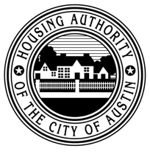
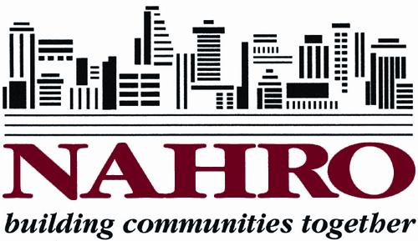
FOR IMMEDIATE RELEASE
Housing Authority of the City of Austin Receives Awards of Merit from NAHRO
(Austin, Texas) - The National Association of Housing and Redevelopment Officials (NAHRO) recently honored the Housing Authority of the City of Austin (HACA) with three 2018 Awards of Merit in the Housing and Community Development Category, Program Innovation: Resident and Client Services. The winning projects were: Resdent Protection Team: Weaving a Safety Net, Involved Dads of Action Developing and Suceeding (I-DADS), and Ambassadors: Resident Change Agents for Innovation.

The Resident Protection Team’s mission is to ease challenges presented when moving, promote community engagement, and develop external partnerships to help HACA better serve residents.

I-DADS empowers and recruits fathers and father-figures in assisted housing communities and encourages self-reflection and participation in topics beyond parenting skills and/or workforce development to aid men in improving their father-child and co-parenting relationships.

Resident Digital, Energy and Mobility Ambassadors provide high-quality, cost-effective program design and development, build professional skills, and the community.

“These agencies have put a lot of thought, creativity and hard work into helping residents improve their lives and into revitalizing their local communities,” said NAHRO President Carl S. Richie, Jr. “I am proud to celebrate their achievements.”

The NAHRO Awards of Merit program was created 19 years ago to recognize agencies who found innovative ways of making a difference in their communities and in the lives of the people they serve by creating affordable housing, revitalizing their neighborhoods, and developing initiatives such as job readiness programs, public-private partnerships, disaster prevention projects, and more.

“Our industry is continuously innovating to address changing local needs and to create new opportunities in their communities,” said NAHRO CEO Adrianne Todman, “Congratulations to this year’s top innovators!”

Contact: Communications Manager Beth Philips, bethp@hacanet.org

About HACA
Established in 1937, HACA is a public unit of government separate from the City of Austin. HACA’s mission is to cultivate sustainable affordable housing communities and partnerships that inspire self-reliance, growth and optimism. As a High-performing housing authority that assists over 20,000 Austinites, HACA owns and operates 1,839 units of subsidized housing in 18 developments throughout Austin. For more information, visit www.hacanet.org, or find us on Twitter @hacanet.

About NAHRO
NAHRO, established in 1933, is a membership organization of nearly 20,000 housing and community development agencies and professionals throughout the United States whose mission is to create affordable housing and safe, viable communities that enhance the quality of life for all Americans, especially those of low- and moderate-income. NAHRO's membership administers more than 3 million housing units for 7.6 million people.

