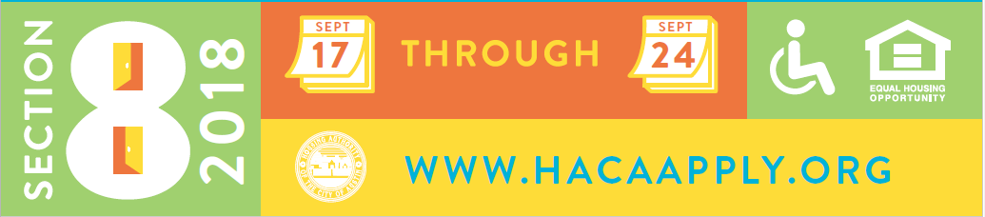

Section 8 Waiting List Opening

HACA will open the waiting list for the Housing Choice Voucher (HCV) Program (also known as Section 8) from noon Sept. 17 to at 11:59 p.m. Sept. 24.

How do I Apply?

All pre-applications must be submitted ONLINE at: www.HACAapply.org. You can apply anywhere they have internet access, from a home computer, laptop, smart phone or tablet. If you do not have internet access at home, you can apply at any public computer with internet access. We have provided a listing of free computer resources at https://www.hacanet.org/residents/assisted-housing/

Computers will not be provided at the HACA central location.

If additional assistance is needed due to a disability, please call 1-888-335-0350 for assistance.

What Information is Needed to Complete the Application?

For every person listed on the application, you will need:
- Full names
- Social Security Numbers (if applicable)
- Birth dates
- Estimated Gross Income
- Valid mailing address

Am I Eligible to Apply?

To be eligible to apply, you must be an adult or a legally emancipated minor, and must not be currently receiving assistance through the HCV voucher program. If a debt to HACA is owed, you are still eligible to apply. However, that debt must be paid in full to be eligible to receive HCV assistance.

Am I Eligible for the Housing Choice Voucher Program?
Eligibility will not be determined at the time you apply. Rather, if you make it onto the waiting list, eligibility will be determined when your name gets to the top of the list. At that time, HACA will review the following eligibility categories to determine if you qualify.

- Does the makeup of the family meet the definition of family used by HACA?
- Is the total gross household income below the income limits for the program at that time?
- Does the family meet the criteria regarding citizenship or eligible immigration status?
- Has the family disclosed all Social Security numbers and signed all required consent forms?
- Have all adult household members passed the criminal background check?
- Are any adult household members on any registered sex offender list?
- Does the family owe a debt to HACA or any other federally assisted housing program?
- Has the family been evicted from federally assisted housing within the past 5 years (from the date the family’s eligibility determination is made, not the date of application)?

For a full explanation of each of these eligibility categories, please click here.

How Will the Random Lottery Selection Work?

HACA will receive pre-applications submitted online between noon on Sept. 17 and 11:59 p.m. on Sept. 24. After the waiting list closes, HACA will begin the process of reviewing all submitted pre-applications. All duplicate and incomplete pre-applications will be removed. Each household can only have one pre-application in the lottery.

Each complete, unduplicated pre-application will be randomly assigned a number. The pre-applications that have been randomly assigned numbers one through 2,000 will move forward to the next step in the process.

After placing the chosen pre-applications onto the waiting list in the order of one through 2,000, HACA will apply the preferences claimed by these families. This will determine the order of families on the waiting list. It will not matter on which open day the applicant applied (the first or the last) or from what location or device; every complete, unduplicated pre-application that is submitted will have an equal chance in the lottery.

How Do I find out if I was selected in the Lottery?

HACA will complete the lottery no later than October 15, 2018. You may find out whether or not you were selected in the random lottery through our application checker.

You will need either your Social Security Number or your confirmation number as well as your date of birth.

You must enter this information exactly as it is on your pre-application.

When you enter this information into the application checker, you will receive a message notifying you if you have been selected or not. If you are not selected in the lottery, please visit our resource page to learn about other housing options.

If you are selected, you will be directed to the Applicant Portal where you can setup your account. In the Applicant Portal, you can check your number on the waiting list, update your current mailing address and report any changes in household members (adding or deleting).

What are the Waiting List Preferences?

Once families are placed onto the waiting list in the order of the random lottery, preferences are applied. A preference moves the family above families without a preference. All families with a preference are put in order by their lottery number listed after families with preferences will be all the families without preferences in order by their lottery number.

The HCV waiting list offer the following preferences:

- Elderly Preference. If the head of household, co-head, spouse are age 62 or older, the family qualifies for this preference.
- Disabled Preference. If the head of household, co-head or spouse is disabled, according to the HUD definition of disability, the family qualifies for this preference.
- Families with Minor Children. If the family has minor children in the household, the family qualifies for this preference.
- Involuntarily Displaced. If the family has been involuntarily displaced by natural disaster or government action within 6 months of the time of application, the family qualifies for this preference.
- Homeless. If the family meets the HUD definition of Homeless and has a referral from a homeless service provider, the family qualifies for this preference.
- Residency. If the family lives within the five county Central Texas area (Travis, Williamson, Hays, Bastrop and Caldwell), the family qualifies for this preference.

Preferences will be verified at the time the family is invited for an interview. If at a later date after submitting the pre-application a family qualifies for a preference, the preference can then be claimed. Preferences can be claimed at any time.

How Do I Update My Information While on the Waiting List?

Families that are on the waiting list are required to keep all their information current. To do this, families must create an account in the online Applicant Portal at http://www.myhaca.org/.

In the Applicant Portal, families can do the following:
- Check what number they are on the waiting list;
- Change their mailing address;
- Update their email address and phone numbers;
- Make changes to family members to be included on the application (adding or deleting).

The Applicant Portal is the primary way for families to communicate with HACA regarding their application while on the waiting list.

It is extremely important for families to keep their information current. When the family name comes to the top of the waiting list, HACA will send a letter inviting the family to an eligibility interview. HACA will use the address listed on file. Failure to keep a current mailing address could result in missing the opportunity to receive housing assistance.

