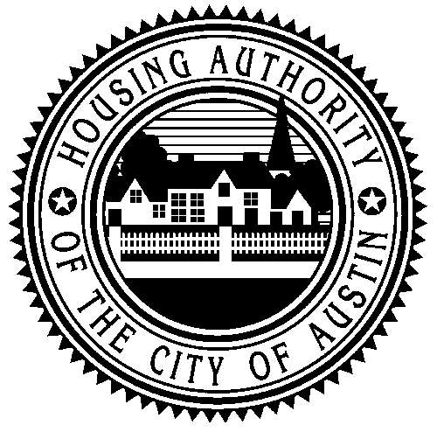 | HOUSING AUTHORITY OF THE CITY OF AUSTIN  1124 South IH35., Austin, TX 78704 (512) 477-1314  P.O. Box 41119, Austin TX 78704 Fax (512) 494-0686

ADDRESS CHANGE ONLY

Please print clearly to ensure timely/accurate disbursement of Housing Assistance Payments.

NEW ADDRESS:

Owner name:
Business Name / Management Company:
Tax I.D.or Social Security No.#
Street Address:
(City) | (State) | (Zip)

Name of Contact Person
Phone #

OLD ADDRESS:

Street Address:
(City) | (State) | (Zip)

